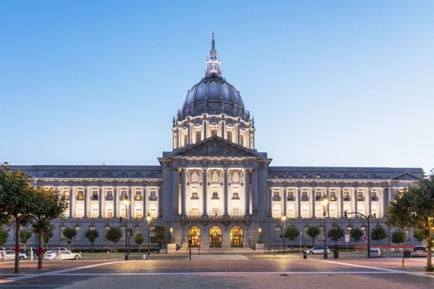**Canadian Government and First Nations Government**

**Name: ____________________**

**Date: _____________________**

Cut the pieces and put your initials on the back. Glue them into the circle that makes the MOST sense. It is okay if they do not fit perfectly!

**Canadian Government Both First Nations Government**