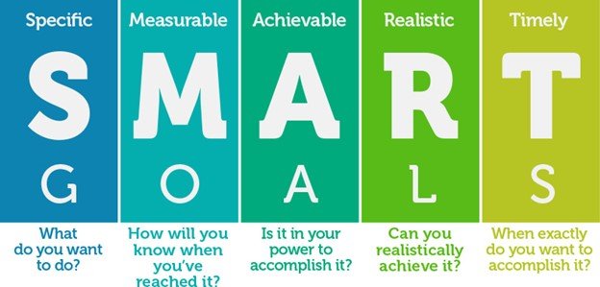

What is my timeline?

How am I going to achieve this?

My fitness goal is: